**LAB ASSIGNMENT – 6**

**DATA TRANSFORMATION & NORMALIZATION**

**NAME : PRATHAPANI SATWIKA**

**REG.NO. : 20BCD7160**

**1.Download the bank.csv file and do the above transformations. After data transformation, save the data into preprocessed_bank.csv file.**

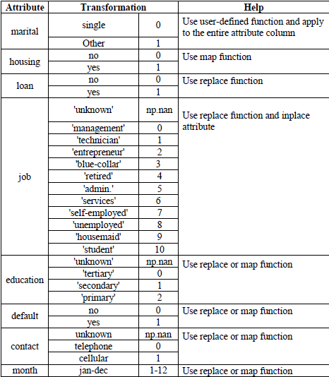  
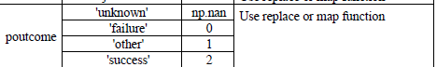  
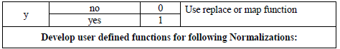

**CODE :**

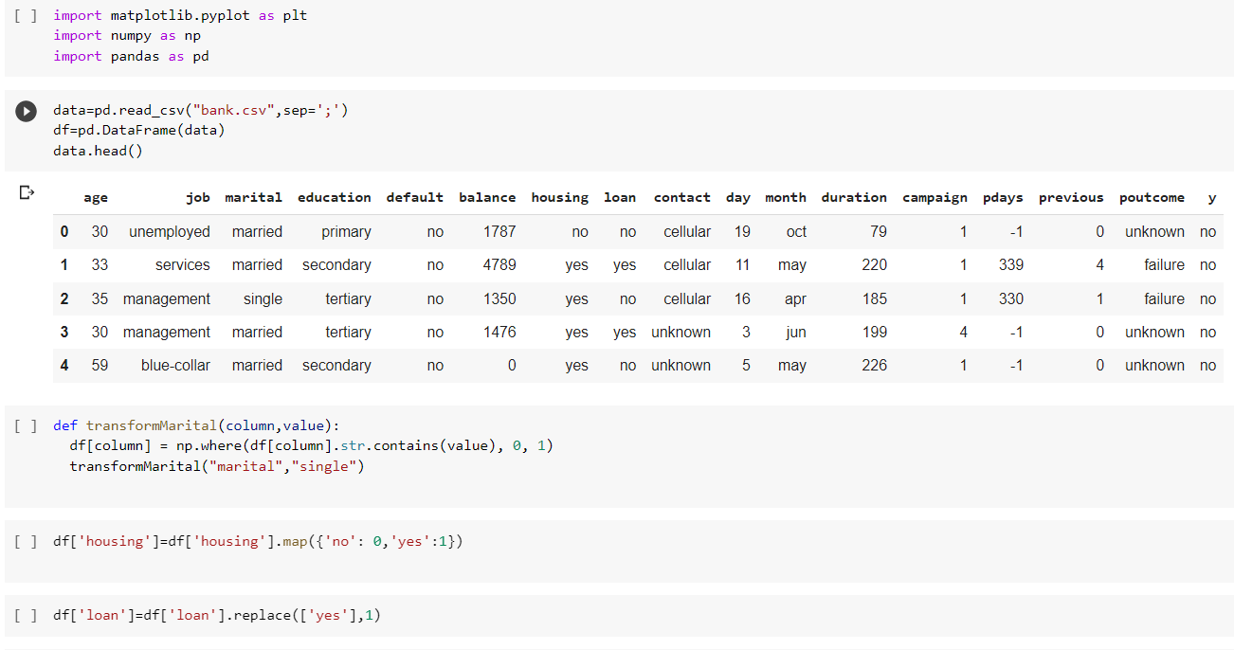

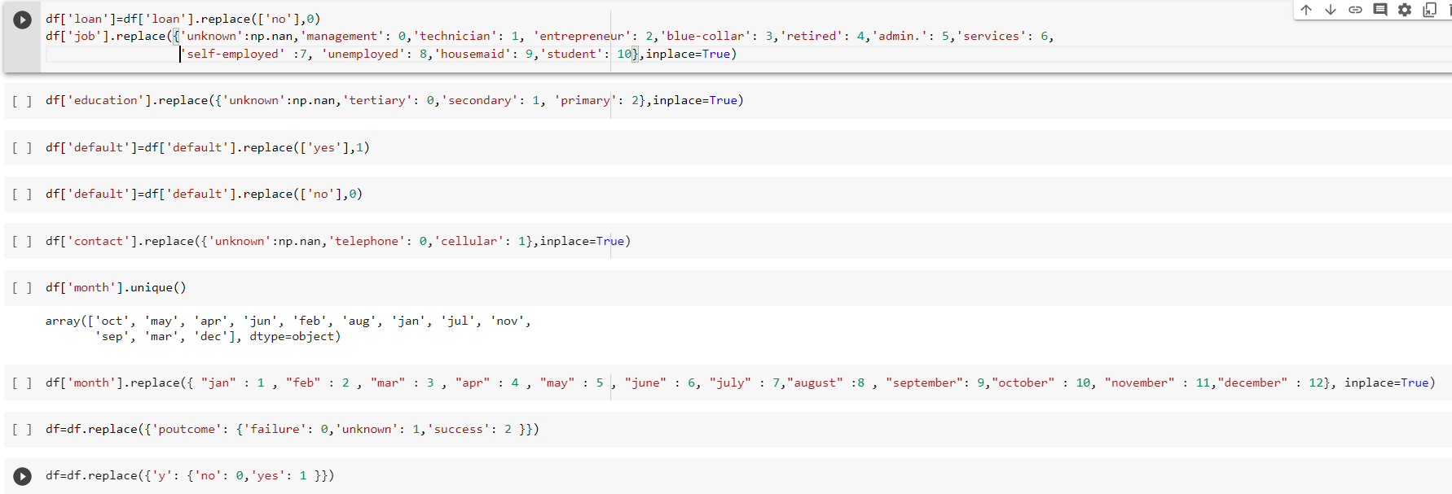

**OUTPUT :**

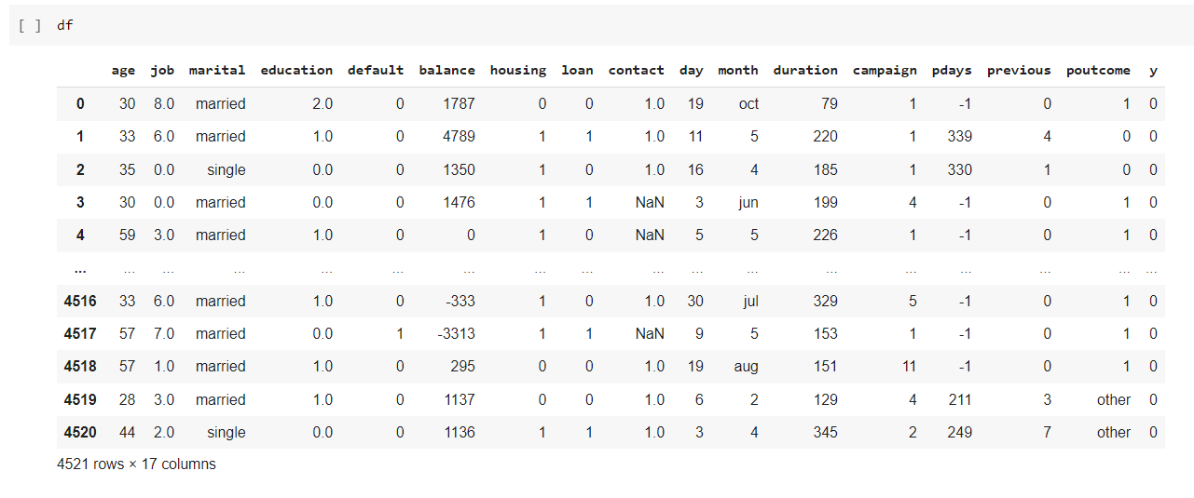

**2. Develop user defined functions for following Normalizations**

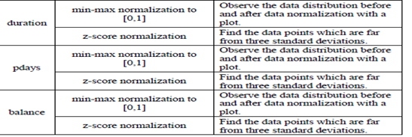

**CODE :**

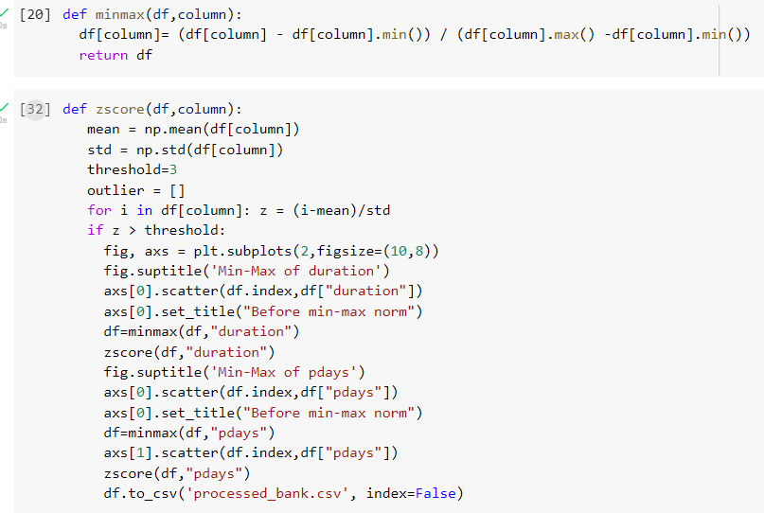

**OUTPUT :**

